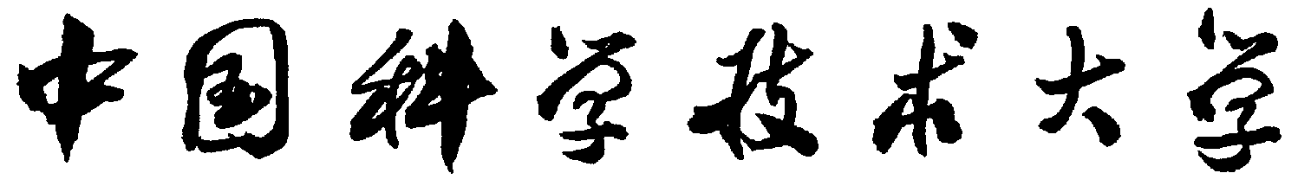
远程合作协议书

为保障疫情期间科研合作项目的顺利实施，中国科学技术大学 学院 （简称甲方）和受聘
人 （简称乙方）本着合法、公平、平等自愿、协商一致、诚实信用的原则和友好合作的精神，签订本协议。
一、 甲方根据学科发展和人才培养的需要，疫情期间聘请乙方借助网络开展远程授课、网络办公。
二、 甲乙双方根据所在院系学科发展的实际需要，协商确定具体的岗位职责和工作目标（以下1/2可选填）：
1.线上讲座主题为：

2.线上授课课程计划安排为（请附课程计划表）：

3.讲座/授课面向对象为：____________ 约____ 人；

4.线上讲座/授课自_____年_____月_____日起至_____年_____月_____日止，共_______次，甲方提供乙方讲课费/薪酬共计人民币_________元（经费发放标准参照《外国文教专家经费管理暂行办法》讲课费资助上限人民币3000元/次）。
三、 乙方为甲方相关学科的发展积极工作，在学科建设、人才引进、青年教师培养、学术团队建设等方面展开工作。
四、 本协议未尽事宜，由甲乙双方共同协商确定。
五、 本协议内容遵照外专来源国及我国相关法律法规执行。
六、 本协议双面打印，自甲乙双方签字盖章之日起生效。

甲方（签字、盖章）： 乙方（签字）：

日期： 日期：
University of Science and Technology of China
Agreement on Remote Collaboration

In order to ensure smooth implementation of collaborative science and research projects during the epidemic, the School of ______________________ of University of Science and Technology of China (Party A) and the hired expert ______________________ (Party B) sign this agreement based on the principle of legal compliance, fairness, equality and voluntariness, consensus, and honesty and in the spirit of friendly cooperation.
I. To meet the needs of disciplinary development and personnel training, Party A hires Party B to teach and work via the Internet during the epidemic.
II. Based on actual needs of disciplinary development of the School, Party A and Party B determine specific job responsibilities and objectives through discussions (Either item 1 or item 2 should be filled in).
1. Theme of the online seminar:

2. Teaching plan and syllabus of the online teaching:

3. Target students of the seminar/teaching: _____________, and the course capacity is _______.

4. Online seminar/teaching starts from ____(day)____(month)_____(year) and ends on ____(day)____(month)_____(year), lasting for _______ times. Party A provides Party B with lecture fees/salary totaling __________ RMB. (The payment standard refers to the "Interim Measures for the Management of Expenditures for Foreign Cultural and Educational Experts". According to the Interim Measures, the upper limit of lecture fees is 3,000 RMB per time).
III. Party B works for Party A to actively promote the development of related disciplines. Party B carries out work in discipline development, talent introduction, training of young teachers, and academic team building, etc.
IV. Matters not covered in this agreement should be determined through consultation between both parties.
V. The contents of this agreement shall be governed by the relevant laws and regulations of the foreign experts’ country and China.
VI. This agreement is printed on both sides and it takes effect from the date of signature and seal of both parties.

Party A (signature, seal): Party B (signature):

Date: Date:

